Registration form for Orange Corners Ideation Challenge 4.0
About Orange Corners Bangladesh
Orange Corners, an initiative by the Netherlands Ministry of Foreign Affairs, empowers young entrepreneurs in Africa, Asia, and the Middle East with training, mentorship, funding, and resources to grow sustainable businesses. Learn more: Orange Corners Bangladesh.
Important information about the Orange Corners Ideation Challenge
The OC Ideation Challenge is an ideation competition which includes a 2-day in-person non-residential bootcamp in Dhaka for anyone aged 18-30 in Bangladesh. Shortlisted teams will join capacity-building sessions during the bootcamp, led by industry experts on turning ideas into business models, with a focus on "Sustainable Cities and Communities." During the bootcamp, participants are expected to engage in sessions on design thinking, market sizing, customer persona creation, pitching, and more, building both entrepreneurial and technical skills. After completion of the bootcamp, top teams will then present their concepts to judges, at the grade finale with winners announced on the final day, earning up to BDT 1 lakh.
Benefits of participating in the OC Ideation Challenge
- Collaborate with diverse, like-minded individuals on a shared goal.
- Gain skills and knowledge to transform ideas into sustainable business models, enhancing future career prospects.
- Win recognition and visibility, opening doors for funding, investment, and partnerships.
- Prizes: BDT 100,000 for the Champion, BDT 50,000 for the Runner-Up, and BDT 25,000 for the 2nd Runner-Up.
- Top teams get a special invitation to join the Orange Corners Incubation Program. However, they still need to go through the application process and pass a review to make sure they qualify.
Eligibility for the OCB Ideation Challenge
- Aged 18-30
- Teams of 2-3 members, with at least one female
- Must submit the registration/proposal/solution in a team
- Solution must focus on urban sustainability(SDG 11)
Program Timeline
- Registration Deadline: November 2, 2024
- Bootcamp Dates: November 29-30, 2024 (Non-residential)
- Event Mode: In-person (Dhaka, Bangladesh)
- Venue: To be announced by Mid November, 2024
No registration fee required.
Submit your team’s form by 11:59 pm on November 2, 2024. For questions, email: bangladesh@orangecorners.com
mahadi.s.neloy@gmail.com Switch account

Draft saved
The name and photo associated with your Google account will be recorded when you upload files and submit this form. Your email is not part of your response.
* Indicates required question
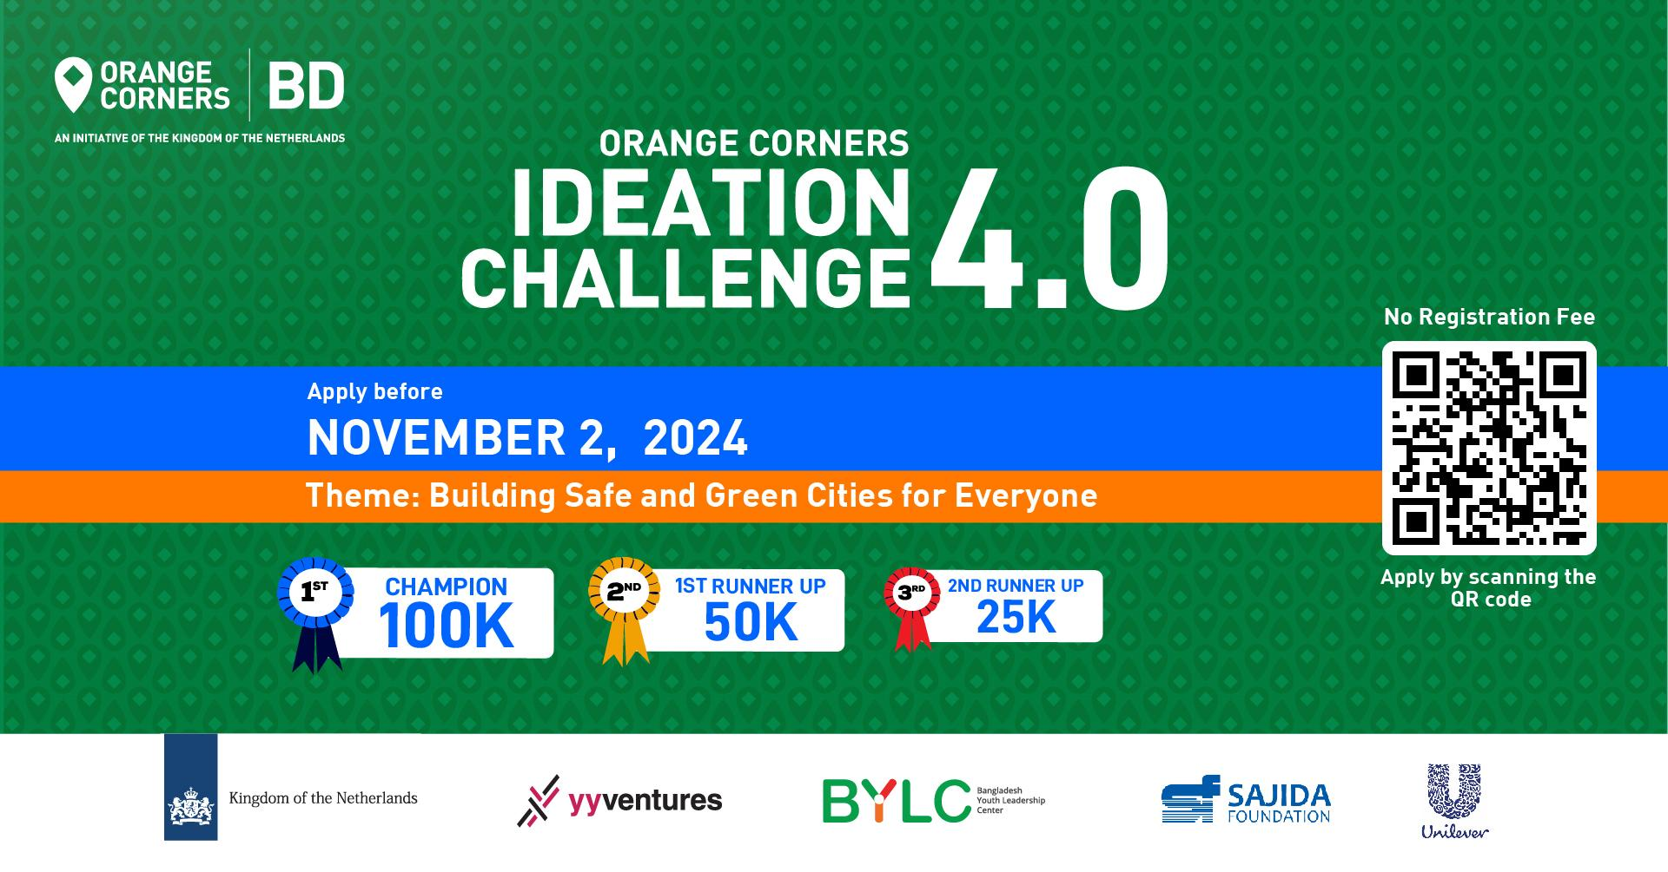
Team name *
How many members are on your team?
*
2
3
Full name (Member 1)
*
Gender (Member 1)
*
Male
Female
Prefer not to say
Email address (Member 1)
*
Contact number (Member 1)
*
University/institute name (Member 1)
*
Full name (Member 2)
*
Gender (Member 2)
*
Male
Female
Prefer not to say
Email address (Member 2)
*
Contact number (Member 2)
*
University/institute name (Member 2)
*
Full Name (Member 3)
Gender (Member 3)
Option 1
Email address (Member 3)
Contact number (Member 3)
University/institute name (Member 3)
Option 1
Theme of the challenge
Theme: Building Safe and Green Cities for Everyone (SDG 11). Sustainable Development Goal (SDG) 11 is all about making cities and communities better places to live. As urban areas grow rapidly due to population increases and migration, challenges like the expansion of mega-cities and the rise of slums become more pronounced. To achieve sustainable development, it’s crucial to transform how we build and manage our cities. This includes improving public transportation, road traffic management creating more green public spaces, inclusive urban planning, more job opportunities, ensuring safe and affordable housing to strengthen communities and economies, and more.

Challenge Statement
University students and young professionals in Bangladesh are invited to participate in an ideation challenge to develop innovative solutions that align with SDG 11 targets. The challenge focuses on transforming urban and rural environments to ensure they are sustainable, resilient, and inclusive. Proposed solutions should address any one or more of the following key targets:

Access to Adequate Housing (Target 11.1): Develop solutions to ensure all residents have access to safe, affordable housing and basic services, and find ways to upgrade slums effectively.
Sustainable Transport Systems (Target 11.2): Create ideas to improve public transportation systems, making them safe, affordable, and accessible, especially for vulnerable groups such as women, children, and people with disabilities.
Inclusive Urbanization (Target 11.3): Propose strategies for the cities to grow in a way that includes everyone, protects the environment, and involves people in the planning process.
Cultural and Natural Heritage (Target 11.4): Develop approaches to protect and preserve cultural and natural heritage within urban settings.
Disaster Resilience (Target 11.5): Innovate solutions to reduce the impact of disasters, including water-related ones, focusing on protecting vulnerable populations and reducing economic losses.
Environmental Impact (Target 11.6): Design strategies to reduce the negative impact that each person in a city has on the environment by focusing on improving air quality and waste management.
Green Public Spaces (Target 11.7): Create accessible and inclusive green spaces that cater to the needs of women, children, older persons, and people with disabilities.

Teams are encouraged to think creatively and propose scalable and impactful solutions that can contribute to achieving SDG 11.
What is the problem you've identified that needs immediate attention? (Select which is most relevant to your solution)
*
Limited access to safe and affordable housing

Insufficient green public spaces
Lack of efficient and inclusive public transportation
Inadequate urban planning and management
High environmental impact from urban activities
Limited disaster resilience measures
Inadequate protection of cultural and natural heritage
Flood management
Water supply and sanitation
Poor road traffic management
Other:

This is a required question
What is your proposed solution? (Explain your solution within 100-120 words)
*
Does your solution have a business model to make it sustainable?
*
If your solution have a business model, please explain a detailed description of your business model, including revenue streams, cost structure, target market, and any partnerships or collaborations that will support the sustainability of your solution
How much funding you need to launch the initiative, in BDT? (You can write N/A if you don't have an actual calculation of the budget during time of the application)
*
How do you plan to utilize the BDT 100,000 prize money if you become the winner of the Ideation Challenge?
*
If you want to add any documents, feel free to utilize this space (Pitch deck, Business proposal, Presentation, Business model canvas, Prototype, Financial plan, others)
Upload 1 supported file. Max 10 MB.
Where did you hear about the program?
*
Search engine
Recommended by friend or colleague
Social Media
Blog or publication
Other:
Never submit passwords through Google Forms.
This form was created inside of Bangladesh Youth Leadership Center. Report Abuse
Forms

Registration form for Orange Corners Ideation Challenge 4.0
About Orange Corners Bangladesh
Orange Corners, an initiative by the Netherlands Ministry of Foreign Affairs, empowers young entrepreneurs in Africa, Asia, and the Middle East with training, mentorship, funding, and resources to grow sustainable businesses. Learn more: Orange Corners Bangladesh.
Important information about the Orange Corners Ideation Challenge
The OC Ideation Challenge is an ideation competition which includes a 2-day in-person non-residential bootcamp in Dhaka for anyone aged 18-30 in Bangladesh. Shortlisted teams will join capacity-building sessions during the bootcamp, led by industry experts on turning ideas into business models, with a focus on "Sustainable Cities and Communities." During the bootcamp, participants are expected to engage in sessions on design thinking, market sizing, customer persona creation, pitching, and more, building both entrepreneurial and technical skills. After completion of the bootcamp, top teams will then present their concepts to judges, at the grade finale with winners announced on the final day, earning up to BDT 1 lakh.
Benefits of participating in the OC Ideation Challenge
- Collaborate with diverse, like-minded individuals on a shared goal.
- Gain skills and knowledge to transform ideas into sustainable business models, enhancing future career prospects.
- Win recognition and visibility, opening doors for funding, investment, and partnerships.
- Prizes: BDT 100,000 for the Champion, BDT 50,000 for the Runner-Up, and BDT 25,000 for the 2nd Runner-Up.
- Top teams get a special invitation to join the Orange Corners Incubation Program. However, they still need to go through the application process and pass a review to make sure they qualify.
Eligibility for the OCB Ideation Challenge
- Aged 18-30
- Teams of 2-3 members, with at least one female
- Must submit the registration/proposal/solution in a team
- Solution must focus on urban sustainability(SDG 11)
Program Timeline
- Registration Deadline: November 2, 2024
- Bootcamp Dates: November 29-30, 2024 (Non-residential)
- Event Mode: In-person (Dhaka, Bangladesh)
- Venue: To be announced by Mid November, 2024
No registration fee required.
Submit your team’s form by 11:59 pm on November 2, 2024. For questions, email: bangladesh@orangecorners.com
mahadi.s.neloy@gmail.com Switch account

Draft saved
The name and photo associated with your Google account will be recorded when you upload files and submit this form. Your email is not part of your response.
* Indicates required question

Team name *
How many members are on your team?
*
2
3
Full name (Member 1)
*
Gender (Member 1)
*
Male
Female
Prefer not to say
Email address (Member 1)
*
Contact number (Member 1)
*
University/institute name (Member 1)
*
Full name (Member 2)
*
Gender (Member 2)
*
Male
Female
Prefer not to say
Email address (Member 2)
*
Contact number (Member 2)
*
University/institute name (Member 2)
*
Full Name (Member 3)
Gender (Member 3)
Option 1
Email address (Member 3)
Contact number (Member 3)
University/institute name (Member 3)
Option 1
Theme of the challenge
Theme: Building Safe and Green Cities for Everyone (SDG 11). Sustainable Development Goal (SDG) 11 is all about making cities and communities better places to live. As urban areas grow rapidly due to population increases and migration, challenges like the expansion of mega-cities and the rise of slums become more pronounced. To achieve sustainable development, it’s crucial to transform how we build and manage our cities. This includes improving public transportation, road traffic management creating more green public spaces, inclusive urban planning, more job opportunities, ensuring safe and affordable housing to strengthen communities and economies, and more.

Challenge Statement
University students and young professionals in Bangladesh are invited to participate in an ideation challenge to develop innovative solutions that align with SDG 11 targets. The challenge focuses on transforming urban and rural environments to ensure they are sustainable, resilient, and inclusive. Proposed solutions should address any one or more of the following key targets:

Access to Adequate Housing (Target 11.1): Develop solutions to ensure all residents have access to safe, affordable housing and basic services, and find ways to upgrade slums effectively.
Sustainable Transport Systems (Target 11.2): Create ideas to improve public transportation systems, making them safe, affordable, and accessible, especially for vulnerable groups such as women, children, and people with disabilities.
Inclusive Urbanization (Target 11.3): Propose strategies for the cities to grow in a way that includes everyone, protects the environment, and involves people in the planning process.
Cultural and Natural Heritage (Target 11.4): Develop approaches to protect and preserve cultural and natural heritage within urban settings.
Disaster Resilience (Target 11.5): Innovate solutions to reduce the impact of disasters, including water-related ones, focusing on protecting vulnerable populations and reducing economic losses.
Environmental Impact (Target 11.6): Design strategies to reduce the negative impact that each person in a city has on the environment by focusing on improving air quality and waste management.
Green Public Spaces (Target 11.7): Create accessible and inclusive green spaces that cater to the needs of women, children, older persons, and people with disabilities.

Teams are encouraged to think creatively and propose scalable and impactful solutions that can contribute to achieving SDG 11.
What is the problem you've identified that needs immediate attention? (Select which is most relevant to your solution)
*
Limited access to safe and affordable housing
Insufficient green public spaces
Lack of efficient and inclusive public transportation
Inadequate urban planning and management
High environmental impact from urban activities
Limited disaster resilience measures
Inadequate protection of cultural and natural heritage
Flood management
Water supply and sanitation
Poor road traffic management
Other:

This is a required question
What is your proposed solution? (Explain your solution within 100-120 words)
*
Does your solution have a business model to make it sustainable?
*
If your solution have a business model, please explain a detailed description of your business model, including revenue streams, cost structure, target market, and any partnerships or collaborations that will support the sustainability of your solution
How much funding you need to launch the initiative, in BDT? (You can write N/A if you don't have an actual calculation of the budget during time of the application)
*
How do you plan to utilize the BDT 100,000 prize money if you become the winner of the Ideation Challenge?
*
If you want to add any documents, feel free to utilize this space (Pitch deck, Business proposal, Presentation, Business model canvas, Prototype, Financial plan, others)
Upload 1 supported file. Max 10 MB.
Where did you hear about the program?
*
Search engine
Recommended by friend or colleague
Social Media
Blog or publication
Other:
Never submit passwords through Google Forms.
This form was created inside of Bangladesh Youth Leadership Center. Report Abuse
Forms

